

SIMATS ENGINEERING

Saveetha Institute of Medical and Technical Sciences Chennai- 602105

Student Name: T.Narasimha Reg. No.:192425233 Course Code: MLA0408 Slot: C
Course Name: Deep Learning
Course Faculty: Dr.D.Sudhagar

Module 2: Facial Emotion Recognition
Module Photographs:
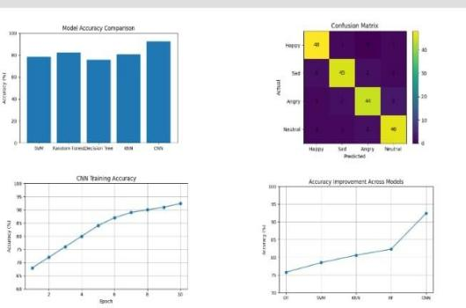
Project Description:
Facial Emotion Recognition is the process of identifying human emotions from facial expressions in an image or video. It uses computer vision and machine learning techniques to analyze facial features and
expressions. Common emotions detected include happiness, sadness, anger, fear, surprise, and disgust. The system first detects the face and then extracts important facial features such as the eyes, eyebrows, nose, and mouth. These features are analyzed to determine the emotional state of the person. Deep learning models, especially Convolutional Neural Networks (CNNs), are commonly used for accurate emotion classification.
Facial Emotion Recognition can work with both static images and real-time video. It is widely used in
applications such as human-computer interaction, security, healthcare, education, and customer analysis. The accuracy of the system depends on image quality, lighting, facial pose, and the training data used.
Modern systems can recognize emotions quickly and automatically. Facial Emotion Recognition helps computers understand human behavior and respond more naturally to users.

